Swiggy vs Zomato Delivery Partner: Kaun Sa Platform Join Karein? Honest Comparison
By Vahan · Updated: 3 July 2026 | Published: 3 July 2026
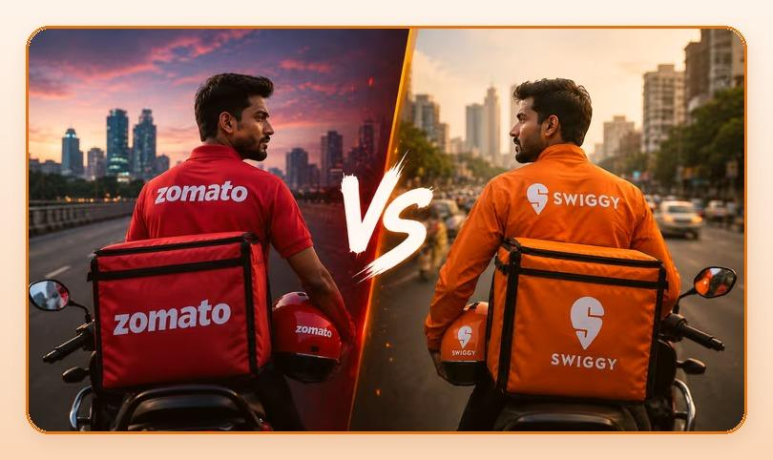
Summarize with ChatGPT · Gemini · Claude · Perplexity (tool icons in design)

Key Takeaways
- Salary, order volume, incentives, working conditions aur growth opportunities, sab kuch honestly compare kiya gaya hai.
- Practical fark bahut chhota hai. Earning mostly depend karti hai city, order volume aur aap kitne ghante kaam karte hain par.
- Sabse smart move yeh hai ki dono platforms par simultaneously registered raho.
- Swiggy aur Zomato dono mein se koi ek aapko bura option nahi hai. Dono se achhi earning possible hai.

Table of Contents
- Swiggy vs Zomato: Quick Overview
- Salary aur Per-Delivery Rate: Kaun Deta Hai Zyada?
- Order Volume: Kahan Zyada Orders Milte Hain?
- Working Conditions: Riders Ka Actual Experience
- Real Riders Ki Raay: Kya Bol Rahe Hain?
- Final Verdict: Swiggy ya Zomato?
- FAQs: Swiggy vs Zomato Delivery Partner Ke Baare Mein Sawaal
- Conclusion: Debate Chhodo, Kaam Shuru Karo

Delivery job join karna decide kar liya, lekin ek sawaal hai jo sabke mann mein aata hai: Swiggy join karoon ya Zomato? Dono bade platforms hain, dono mein kaafi riders hain, lekin experience aur earning mein fark hota hai. Agar aap ek baar mein sahi decision lena chahte hain, to yeh detailed comparison sirf aapke liye hai.
Hum yahan salary, order volume, incentives, working conditions aur growth opportunities, sab kuch honestly compare karenge. Koi platform ka promotion nahi, sirf facts.

Swiggy vs Zomato: Quick Overview
Feature | Swiggy | Zomato
Founded | 2014 | 2008
Delivery Partners | 3 lakh+ | 3 lakh+
Cities Active | 500+ | 800+
Services | Food, Instamart, Genie | Food, Zomato Gold, Hyperpure
Payment Cycle | Weekly | Weekly
App Rating (Rider) | 3.8/5 | 3.9/5

Salary aur Per-Delivery Rate: Kaun Deta Hai Zyada?
Yeh sabse important comparison hai. Dono ki earning structure similar hai, lekin kuch differences hain:
Earning Type | Swiggy | Zomato
Base Per Delivery | Rs.20 - Rs.45 | Rs.18 - Rs.42
Peak Hour Bonus | Rs.5 - Rs.15 extra/delivery | Rs.5 - Rs.20 extra/delivery
Monthly (Full-Time) | Rs.18,000 - Rs.28,000 | Rs.17,000 - Rs.26,000
Rainy Day Bonus | Yes, higher surge | Yes, surge pricing
Festival Incentives | Rs.2,000 - Rs.8,000 | Rs.2,500 - Rs.7,000
Order Target Bonus | Weekly targets | Weekly targets

Practical fark bahut chhota hai. Earning mostly depend karti hai city, order volume aur aap kitne ghante kaam karte hain par. Kisi ek city mein Swiggy better ho sakta hai, doosri city mein Zomato.

Delivery Job Chahiye? Vahan.co par Apply Karein.
Get Started

Order Volume: Kahan Zyada Orders Milte Hain?
Order volume seedha aapki earning se connected hai. Jitne zyada orders, utni zyada earning. Is maamle mein:
- Swiggy: Instamart (grocery) aur Genie (pickup-drop) ki wajah se non-meal-time par bhi orders milte rehte hain. Yeh ek bada advantage hai.
- Zomato: Pure food ordering platform, isliye peak hours (lunch aur dinner) ke baad orders drop hote hain. Lekin 800+ cities mein presence matlab Tier-2/3 cities mein better coverage.
- Conclusion: Metro cities mein Swiggy ke non-food services ki wajah se orders zyada consistent hote hain. Smaller cities mein Zomato ka wider presence faydement hai.

Working Conditions: Riders Ka Actual Experience
Salary ke alawa kuch important factors hain jo daily experience affect karte hain:
Factor | Swiggy | Zomato
App Usability | Smooth, regular updates | Good, slightly complex
Support Response | Chat + call support | Chat support, slower
Onboarding Time | 3-5 days | 3-7 days
Uniform / Kit | Provided free | Provided free
Insurance | Accident cover included | Accident cover included
Ratings System | Order acceptance + delivery rating | Customer rating based

Real Riders Ki Raay: Kya Bol Rahe Hain?
"Maine dono try kiye hain. Mumbai mein Swiggy better hai kyunki Instamart ke orders bhi milte hain. Afternoon mein bhi kaam rehta hai." (Vikas, 29, Mumbai)
"Jaipur mein Zomato ka zyada share hai. Orders consistent milte hain. Swiggy yahan itna strong nahi." (Rajan, 24, Jaipur)
"Main dono pe hoon. Jo app pe pehle order aaye, wo le leta hoon. Monthly earning dono milake Rs.30,000 se upar ho jaati hai." (Ajay, 31, Bangalore)

Final Verdict: Swiggy ya Zomato?
Ek line mein answer nahi hai. Yahan situation-wise recommendation hai:
- Metro city mein ho: Swiggy slightly better hai, Instamart orders ki wajah se income more consistent.
- Tier-2 ya Tier-3 city mein ho: Zomato ka wider coverage kaam aata hai.
- Maximum earning chahiye: Dono join karo, simple.
- Pehli baar join kar rahe ho: Jo bhi aapki city mein zyada popular hai, wahan se shuru karo.
Sabse smart move yeh hai ki dono platforms par simultaneously registered raho. Zomato aur Swiggy dono allow karte hain. Is tarah earning maximize hoti hai aur slow days ka risk khatam hota hai.

FAQs: Swiggy vs Zomato Delivery Partner Ke Baare Mein Sawaal
Q: Kya main Swiggy aur Zomato dono pe ek saath kaam kar sakta hoon?
Haan, dono platforms simultaneously use karne mein koi restriction nahi hai. Aur yeh sabse common strategy bhi hai zyada earn karne ke liye.
Q: Swiggy Instamart aur regular food delivery mein kya fark hai?
Instamart grocery delivery hai, grocery store se customer ke ghar tak. Yeh orders typically chhote aur frequent hote hain, aur non-meal-time par bhi aate hain.
Q: Kaun sa platform jaldi payment karta hai?
Dono weekly payment karte hain directly bank account mein. Kuch markets mein daily payout option bhi available hai.
Q: Kya Zomato Gold ya Swiggy One se riders ko koi benefit milta hai?
Ye customer subscription programs hain. Delivery partners ke liye direct benefit nahi hota, lekin in programs se order volume badhta hai, jo indirectly earning improve karta hai.
Q: Nayi city mein shift hone par kya karna padega?
Dono platforms mein city change process hoti hai. Apne rider support se baat karo aur new city mein documents re-verify karwa lo.

Conclusion: Debate Chhodo, Kaam Shuru Karo
Swiggy aur Zomato dono mein se koi ek aapko bura option nahi hai. Dono se achhi earning possible hai. Sabse important cheez yeh hai ki aap join karo, kaam karo, aur apni city mein kya better kaam karta hai yeh khud experience karo.
Vahan.co par aap ek hi jagah se Swiggy aur Zomato dono ke liye apply kar sakte hain. Free hai, 2 minute lagta hai, aur kal se earning shuru ho sakti hai.
Abhi Apply Karo: vahan.co/jobs

Delivery Job Chahiye? Vahan.co par Apply Karein: vahan.co/jobs

